**KPI’s Requirement**

We need to analyse key indicators for our pizza sales data to gain insights into our business performance. Specifically, we want to calculate the following metrics:

1.Total Revenue: The sum of the total price of all pizza orders.

select sum(total_price) as total_revenue from pizza_sales

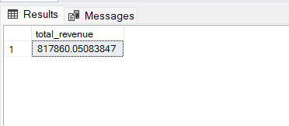

2.Average Order Value: The average amount spent per order, calculated by dividing the total revenue by the total number of orders.

select sum(total_price)/count(distinct order_id) as average_order_value from pizza_sales

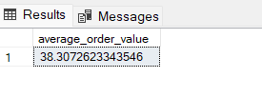

3.Total Pizzas sold: The sum of the quantities of all pizzas sold.

select SUM(quantity) as Total_Pizza_sold from pizza_sales

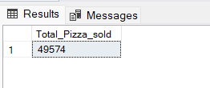

4.Total order placed: The total number of orders placed.

select COUNT(distinct(order_id)) as Total_order_placed from pizza_sales

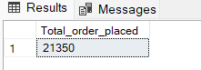

5.Average_pizza_per_order: The average number of pizzas sold per order, calculated by dividing the total number of pizzas sold by the total number of orders.

select cast(cast(sum(quantity) as decimal(10,2))/cast (count(distinct order_id)as decimal(10,2))as decimal(10,2)) as average_pizza_per_order from pizza_sales

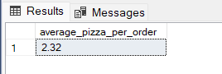

**Charts Requirement**

We would like to visualize various aspects of our pizza sales data to gain insights and understand key trends. We have identified the following requirements for creating charts:

1.Daily trend for total orders : Create a bar chart that displays the daily trend of total orders over a specific time period. This cart will help us identify any patterns of fluctuations in order volumes on a daily basis.

select DATENAME (dw, order_date) as order_day, count(distinct order_id) as total_orders from pizza_sales group by DATENAME(dw, order_date)

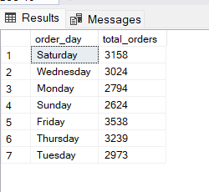

2.Hourly trend for orders: Create a line chart that illustrates the hourly trend of total orders throughout the day. This chart will allow us to identify peak hours or periods of high order activity.

select datepart(hour, order_time) as order_hours,

count(distinct order_id) as total_orders from pizza_sales

group by datepart(hour, order_time)

order by datepart(hour, order_time)

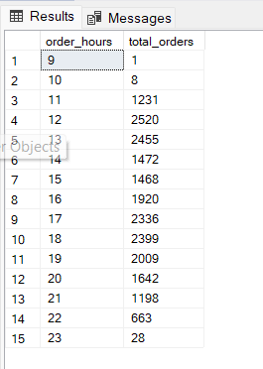

3.Monthly trend for total orders: Create a line chart that illustrates the hourly trend of total orders throughout the month. This chart will allow us to identify the sale of demand of pizzas on monthly basis.

select DATENAME(month, order_date) as Month_name, count(distinct order_id) as Total_orders

from pizza_sales

group by DATENAME(month, order_date)

order by Total_orders desc

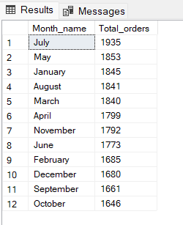

4.Percentage of sales by Pizza Category: Create a pie chrt that shows the distribution of sales across different pizza categories. This chart will provide insights into the popularity of various pizza categories and their contribution to overall sales.

select pizza_category, sum(total_price) * 100 / (select sum(total_price) from pizza_sales) as PCT_Total_sales

from pizza_sales

group by pizza_category

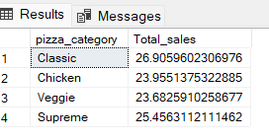

4.Percentage of sales by pizza size: Generate a pie chart that represents the percentage of sales attributed to different pizza sizes. This chart will help us understand customer preferences for pizza sizes and their impact on sales.

select pizza_size,

cast (sum(total_price) as decimal(10,2)) as Total_sales,

cast(sum(total_price) * 100 / (select sum(total_price) from pizza_sales) as decimal(10,2)) as PCT_Total_sales

from pizza_sales

group by pizza_size

order by PCT_Total_sales desc

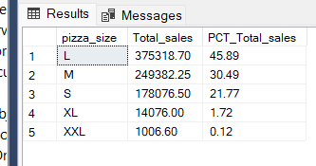

5.Total pizzas sold by pizza category: Create a funnel chart that presents the total number of pizzas sold for each pizza category. This chart will allow us to compare the sales performance of different pizza categories.

select distinct (pizza_category) as pizza_cat, sum(quantity) as pizza_sold from pizza_sales group by pizza_category

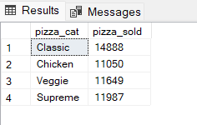

6.Top 5 best sellers by revenue, total quantity and total orders: Create a bar chart highlighting the top 5 best-selling pizzas based on the Revenue, Total Quantity, Total Orders. This chart will help us identify the most popular pizza options.

select top 5 pizza_name, sum(total_price) as total_revenue from pizza_sales

group by pizza_name

order by total_revenue desc

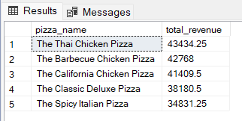

select top 5 pizza_name, sum(quantity) as total_quantity from pizza_sales

group by pizza_name

order by total_quantity desc

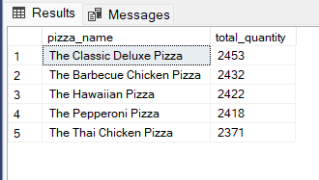

select top 5 pizza_name, count(distinct order_id) as total_orders from pizza_sales

group by pizza_name

order by total_orders desc

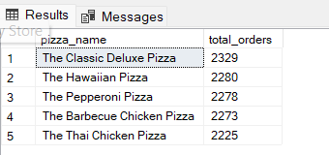

7.Bottom 5 best sellers by revenue, total quantity and total orders: Create a bar chart highlighting the bottom 5 best-selling pizzas based on the Revenue, Total Quantity, Total Orders. This chart will help us identify the less popular or underperforming pizza options.

select top 5 pizza_name, cast(sum(total_price)as decimal(10,2)) as total_revenue from pizza_sales

group by pizza_name

order by total_revenue asc

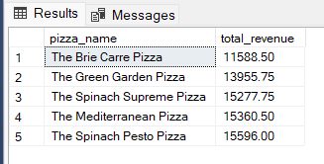

select top 5 pizza_name, sum(quantity) as total_quantity from pizza_sales

group by pizza_name

order by total_quantity asc

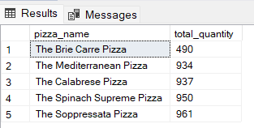

select top 5 pizza_name, count(distinct order_id) as total_orders from pizza_sales

group by pizza_name

order by total_orders asc

